The Great Houses of Leyton and
Leytonstone

The Grange

With emphasis on the Lane Family
and the Slave Trade

David Ian Chapman

Leyton & Leytonstone Historical Society
The Grange , with emphasis on the Lane Family and the Slave Trade

Number 2 in the Great Houses of Leyton and Leytonstone Series

Occasional Publication No 6

The author would like to acknowledge the help and assistance of David Boote.

Published in 2007 and printed in 2016 by

Leyton & Leytonstone Historical Society
27 The Croft
London
E4 6EZ

Website : www/leytonhistorysociety.org.uk
The Grange

The history of the Manor of Leyton or Leyton Grange can be traced back to the compilation of the Doomsday Book. The Grange estate lay between the Manors of Marks, partly in Walthamstow, and that of Ruckholt, but its exact parameters have not been accurately plotted. For a more detailed history of the Manor from Doomsday to circ 1650 see An Account of the History of the Manor of Leyton, an unpublished monograph by Frederick Temple. This was the basis of a paper read to the members of the Leyton Antiquarian Society in early 1929.

The purpose of this monograph is to describe the history of the last house to bear the title of The Grange. The word “Grange” means an outlying Manor Farm of an Abbey and indicates that the land once belonged to the monks of Stratford Langthorne.

An earlier house is thought to have been demolished circa 1648, although the gatehouse is said to have remained.

Gansel

In 1649 Sir Thomas Lake, the younger, whose father had been Secretary of State to King James I, sold his holding of the Manor to three gentlemen namely, Captain George Swanley, Bernard Ozler and Robert Abbot. Captain Swanley’s share, which included the site of the Manor House, its Gatehouse and gardens, eventually passed to his three daughters. Their shares were acquired separately by one John Chinnall, who in his turn sold these to David Gansel, the elder, in 1703. Gansel also obtained the share owned by the relations of Bernard Ozler in 1710.

The Huguenots were French Protestants who fled France following the Dragonnard Campaign, which began in 1681. Huguenots were being pressured to convert to Catholicism before their religion was outlawed with the Revocation of the Edict of Nantes in 1685. Many escaped to The Netherlands or across the channel to England or even further afield to America. In London settlements began in Soho and in and around Threadneedle Street in the City where there were already established churches.

Two such families who left France were the Gansel and Marescoe. David Gansel travelled to England in 1684 from Rouen in northern France. Almost the first record we have of him is in 1689 with the christening of a son in Hackney. So it is reasonable to assume that they had migrated east from Spitalfields.

Another French Huguenot family were the brothers Pierre and Charles Marescoe. They left Lille to settle in London in the 1650s. By 1670 Pierre Marescoe was living in Threadneedle Street. Charles Marescoe, a merchant with interests in the East Indies, was living in Leyton with his wife Leonora Lethieullier where a daughter, Anne, was born 9 March 1665. Her father died 9 September 1670 and was buried in St Mary’s Parish Church on 16 September 1670, aged just forty years of age.

Anne Marescoe married David Gansel in 1688. They may have now been living in Hackney before moving to Leyton by 1695. David Gansel first appears in the Rate Books from Lady Day 1695, although it is not known where they lived until 1706, when they moved to the newly rebuilt Leyton House. This house stood in Church Road, opposite to the end of Capworth Street.

Prior to leaving Hackney, the Gansels, first born son, David, was christened on 24 April 1689, but died shortly afterwards. A second son, was also christened David on 15 January 1690 at St. John’s Parish Church. His father was active in the local affairs of Leyton being an Overseer of the Poor in 1703 and Constable in 1708. Elected to Churchwarden in 1710, his duties were performed by William Say. This may have been due to ill health as he died and was buried at St Mary’s Parish Church on 3 December 1714.

Following his father’s death Leyton House passed to David Gansel, the younger. He married Margaret Ward, whose father was William Ward, the proprietor of the Alum Works, of Hackney at St Mary’s Leyton on 4 November 1714. The births of their three children followed in quick succession - William was baptised on 5 October 1715, Anne baptised 1 August 1716, and Charles baptised 23 September 1719, dying in 1734.

This young man now set about to design a new or replacement for the Grange House. The Rev John Kennedy in his History of the Parish of Leyton, in Essex, reproduces a superb double page spread showing an engraving of Leyton Grange in the County of Essex, the seat of David Gansel Esq., was designed and executed it himself 1720. It was engraved by T Schynvoet who is believed to have come to London in 1700 and drew The Grange sometime between 1720/3. It was published in Le Noveau Theatre de la Grande Bretagne, four volume edition dated 1729.

Clearing the site prior to building must have started in 1718. In a paper read to the Leyton Antiquarian Society by A H Fowler in 1927 on Roman Leyton he mentions David Gansel making an important find.

When enlarging his garden near the (site of) Manor House, he found very large and strong foundations with arches, and an arched doorway ten feet high and six feet broad. The wall was four feet thick. Steps leading down, which were littered with Roman bricks, tiles and Egyptian granite and digging a pond north of the churchyard they found a great quantity of oak beams eight by ten inches square mortised together. . . . . In 1735 digging to plant trees a Roman pavement was found measuring twenty feet by sixteen feet. This was not uncovered

The pond mentioned above was probably the fishponds made by the monks.

The Grange must have been ready for occupation by mid 1720, for on 17 June in the presence of the Court Baron, David Gansel passed the tenancy of the Manor of Leyton, and Leyton House, to John Phillips.

The plan of the elevation of the new house appeared in the third volume of Vitruvius Britannicus (or the British Architect), from a drawing by Colen Campbell and engraved by H Hulsbergh and published in 1731. The dimensions are said to be 60 feet long by 50 feet wide.

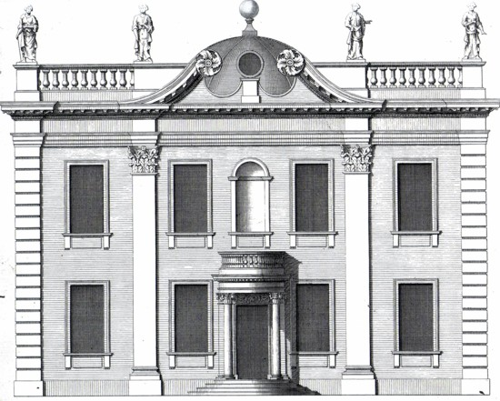

The stone built Georgian building consists of two stories with a central doorway reached by a series of four steps, a-topped with a semi circular doorway resting on two pillars. The front is lit by four windows on each floor with three windows on each of the other three sides. At roof level above a balustrade are four sculptured classical female figures.
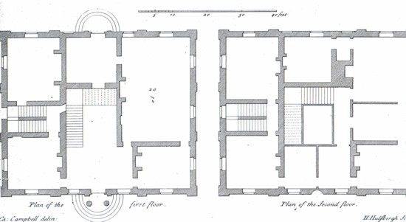

The front entrance led through to a large hall with a staircase leading up to the first floor, on the left. On the ground floor are six rooms including a large saloon. Entering from the front entrance, working round from the right hand side, is the library, the drawing room, the morning room, and on the other side another morning room and an anti-room opening out into the dining room. This room connected to the kitchen wing added in the time of Sir John Strange, but not shown on the above plan. Strange also added to the right hand wing, a brewery. In the drawing room set into the wall above a marble mantle-piece was a portrait of Henrietta Maria. On the upper first floor there are eight main rooms.

From the birds eye view of the grounds and gardens the main house is shown in the centre, the site of which would lie beneath the present day Grange Park Road. In the bottom left hand corner is the Parish Church of St Mary’s, which enables us to locate the site of the Grange with some accuracy. Leading from the church are a line of trees. These may well have been lime trees, several old examples of which were moved from outside the Vicarage when Church Road was widened in the early thirties. The old Vicarage itself was destroyed in 1957 when it made way for the John Strype Court, named after the Leyton Vicar and noted historian. The rest of the formal gardens were laid out by David Gansel in the style prevalent at the time of the French garden designer, Andre la Notre.

Not shown in this view was the arched gateway believed to have existed from the remains of the previous house. Attached to the Gatehouse were flanking lodges. The main drive leading to the house, from what would have been the High Street (better shown in the map of 1860) were said to be chestnut trees. This close was called “The Yorkshire” and was entered by a gate situated about where the garage is today.

Beyond the house lay the formal gardens stretching down the hill to the pond, site of the present day Primrose Road. The avenue of trees on the right hand side correspond with the present day Vicarage Road. In the bottom right hand corner there was a small gate, which opened out into the High Road exactly where Vicarage Road commenced (almost opposite the Salvation Army Barracks, but today a petrol station). This gate was open on Sundays when the children were allowed to use the lovely old gravel path to walk through the avenue of lime trees to the churchyard.

At the far end of the avenue (now Vicarage Road) was a ring of trees at which point the ornamental ponds ends. As late as 1939, two of these trees were still standing in the gardens of 91/93 Vicarage Road. They were pronounced by Borough officials to be over 200 years old. As of 2007 one of these houses has been demolished, but at the rear of 85 Vicarage Road, part of the replacement terrace, backing onto the grounds of George Mitchell School, stands an old tree. Whether this is one of the two older trees is questionable.

The furthest part of the garden is the boundary formed by what is today the descriptive Park Road.

Fragments from the old house existed well into the 20th century. At the corner house, called Grange Lodge, on the corner of Grange Park Road and Church Road were a set of iron railings which are said to have come from the house.

Unfortunately, number 8 Grange Park Road, the home of the well known Dr Badenock was demolished during the blitz in 1940. The house contained the banisters of the staircase and also the two porch pillars. The sills of two of the ground floor windows were set up on the capitals of the two great pillars.

It is said that the gateway to the old Bowling Green Tavern which was adjacent to Leyton House came originally from The Grange. Finally a piece of statuary was apparently presented by a Mr Roberts of Walthamstow to Leyton Library.

David Gansel remained in occupancy of The Grange through to Lady Day 1733, when he moved to East Donyland Hall. In 1730 he had purchased East Donyland Hall, near Colchester, although the sale was not completed until 1735. David Gansel died there in 1753.

The black sheep of the family was his son, William Gansel. Through the influence of his uncle Joshua Ward, William gained a commission into the Coldstream Guards in 1734. He rapidly rose through the ranks from Lieutenant, Captain, Colonel and finally Lieutenant General by 1772. For the last few years of his military career he ran into financial troubles. Around 1769 he was arrested for debt. Then in September 1773 he was tried at the Old Bailey for breaking the peace. He was acquitted of the charge of shooting at John Hyde, a bailiff, in St Martin’s in the Fields. For the last few months of his life he was held in a debtors prison. He died in the infamous Fleet Prison on 28 July 1774 when falling from a chair during an apoplectic fit and is interred in the family vault in East Donyland Church.

According to Daniel Lysons the Gansels move to East Donyland caused the lease of the Grange House to be sold off separately to Sir John Strange around 1735, whilst retaining ownership of the manor estates.

General Gansel having died in debt his affairs passed into Chancery and it was not for nine years that his two thirds share of the Manor estates was able to be sold. The purchaser was John Pardoe, a director of the Honourable East India Company.

Strange

Sir John Strange, born 1696, became Solicitor General to King George II in 1735, and later appointed Master of the Rolls 11 January 1749. He married Susanna Strong, the daughter of the mason responsible for the building of St Paul’s Cathedral. She died on 21 January 1747 and was buried at St Mary’s eight days later. The couple had a large family - the eldest son, John, daughter Martha, who married James Wittewrong 29 June 1745 and was buried 4 December 1758, daughter Letitia baptised 23 August 1736, son Matthew baptised 2 March 1744 and buried 4 January 1760, and a daughter Emma who was buried 5 February 1764. Their third daughter, Mary, married George Narves at St Mary’s Parish Church on 1 October 1751. Her husband was a High Court Judge and won the General Election in 1768 and was returned as Member of Parliament for Oxford. He was elected to the Court of Common Plea and knighted in 1771, before dying in 1786.

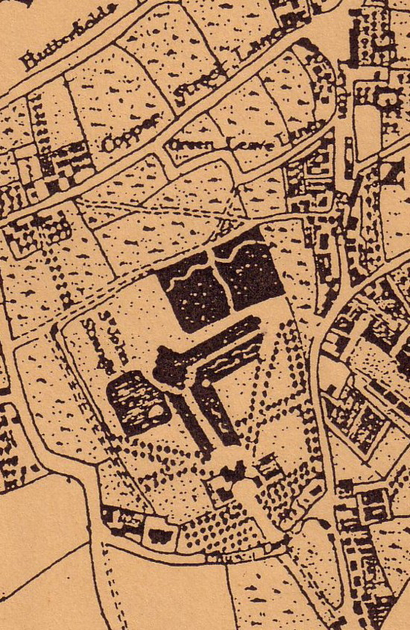
Sir John Strange appears in the rate books from Lady day 1735 to Michaelmas Day 1755, although having died in May 1754, and been buried in St Mary‘s Churchyard. There is no truth in the saying that his tombstone contained the line Here lies an honest lawyer, that is Strange. During Sir John Strange’s residency the estate is clearly shown on John Rocque’s map Carte Topograhique des villes de Londres et de Westminster, du bourge de Southwark et de leurs environs, 1746 (see next page). John Kennedy stated that Sir John improved his seat with additional buildings as well as remodelling the gardens in 1735. Looking at the map there appears to be two wings added to the rear of the house. Also shown on the map is the Workhouse, built in 1742 on ground behind the Alms-Houses and leased from David Gansel for 99 years. What is odd is that the Alms-Houses, shown next to the Parish Church, were not shown on the engraving of 1720, although completed 70 years earlier.

After the death of Sir John Strange, on 18 May 1754, The Grange was sold by his son, John Strange (buried 29 March 1795), to Thomas Bladen.

Bladen

The most famous occupant of The Grange was the American born Thomas Bladen, who became Colonial Governor of the State of Maryland. His father William Bladen had been born in Yorkshire on 27 February 1673 and at some time travelled to the new world. Here he met and married Ann Van Swearingen, of Dutch descent, in 1696 in St Mary County. They had three children, Thomas, born 23 February 1698, an older sister, Ann born c1696 and another son, Christopher in 1700.

Thomas Bladen inherited over 16,000 acres of land, along with 26 slaves, on the death of his father in 1718. His uncle, Martin Bladen, was a director of the Royal African Company from 1717 to 1726, whose ships at one time held a monopoly for the Atlantic slave trade.

Back in England Thomas Bladen became a Member of Parliament for Steyning 1727 - 1734 and for Ashburton in Derbyshire 1735 - 1741. On 14 July 1731 Thomas Bladen married Barbara Janssen, the sister of Lady Baltimore, at St Stephen Walbrook in the City of London. They had two daughters, the eldest Barbara, born 1738, married Henry St John 31 August 1771. Her sister, Harriet, born 1742, became the wife of George Capell - Coningsby, the 5th Earl of Essex, when they married 2 March 1767.

Lady Mary Baltimore, wife of Charles Calvert, 5th Earl of Baltimore, proprietor of Maryland. It was Lord Baltimore who appointed Thomas Bladen Colonial Governor of Maryland in 1742, when the Bladens returned to Maryland. He remained in office for four years, when having been dismissed for being “tactless and quarrelsome“. He returned to England and lived in Leyton where he first appears in the rate books from Lady Day 1756 and on through to Michaelmas Day 1779. He was made a Churchwarden in 1763 and 1769 and Surveyor of Highways in 1764. Thomas Bladen died in Leyton in 1780 and was buried in the parish churchyard. His widow Barbara Bladen paid the rates for the next quarter.

Brassey

The next occupants were Nathaniel and Mary Brassey. Taking over payment of the rates from Michaelmas Day 1780 through to Lady Day 1797. Nathaniel Brassey was born in June 1752 and related to the London Bankers, John and Nathaniel Brassey & Lee of the Acorn, Lombard Street. The firm had been founded back in 1697 by John Brassey, a London Goldsmith. By the time Nathaniel joined the firm it was trading under the name of Brassey, Lee & Ayton.

Nathaniel Brassey had married Mary Lee, born 1757, in Edmonton 12 January 1776. Whilst resident in Leyton the couple had four children, George born 13 January 1782, Louisa baptised 13 November 1784, Nathaniel born 26 August 1786 and Willoughby born 23 October 1787. Although an earlier child, Nathaniel had been born in 1777 and died at Leyton 12 September 1782.

Like most of the previous occupiers of the Grange Nathaniel took his position in the community seriously being the Overseer of the Poor in 1783 and 1785 and Churchwarden in 1792/3. As the owner of the big house by the church, it would have been the venue for the marriage of the Rev Henry Patterson and Sophie Lee, witnessed by Nathaniel Brassey in 1786. Just prior to his death Nathaniel Brassey sold the lease of the house to Thomas Lane on 22/23 June 1796 for £8,400. He died 18 September 1798 and was buried in Hertingfordbury churchyard, close to the family home of Roxford. Mary Brassey died 26 November 1814 and is buried alongside her husband.

Thomas Lane

The head of the next family to purchase The Grange was the successful London based solicitor, Thomas Lane. They were a family who could trace their roots back to William the Conqueror. It was one of his forebears, Jane Lane, who helped Prince Charles, later King Charles II, to escape from Cromwell’s forces after the Battle of Worcester in 1651. Thomas Lane had been born on 30 September 1754 in Kings Bromley, north of Lichfield, the second son of John Lane and his wife Sarah Fowler.

He married Barbara Fowler of Pendeford, Stafford on 4 September 1784, just short of his thirtieth birthday. The Lanes first appear in the rate books from 1796. By then the family consisted of five children. The eldest son was Thomas Goldsmith Fowler, born 5 November 1786, dying before his father on 10 April 1819. His second son, John, born 6 June 1788. The only surviving daughter was Sarah, born 31 May 1790, who married William Cotton of Wallwood on 4 February 1812. She died 21 December 1872. Charles, born 2 February 1793, became rector of Wrotham, dying 23 March 1879. The youngest son, Richard Stuart was born 2 October 1794, and died 27 January 1870. The latter clearly shows the family’s strong lasting allegiance to the Jacobite cause.

Thomas Lane was in private practice and also solicitor clerk to the Goldsmiths’ Hall. In parochial affairs he was Overseer of the Poor in 1797 and 1798 and again in 1802 and also Churchwarden from 1800 to 1816.

On 30 April/1 May 1813 Thomas Lane obtained the lease on the land lying south of Church Lane, which had been retained by the Gansel family. Following William Gansel’s death the inheritance passed down to David Jebb of Slaine, County Meath, the only surviving son of Rev John Jebb, Dean of Cashell, and Ann or Anne Gansel.

For the first twenty years of the Lane’s occupancy of The Grange, Thomas Lane kept a meticulous record of their household and farm expenses. These throw a remarkable insight into the life of a middle class family in the early days of the 19th century. A summary of the first year expenses at The Grange amounted to over £2500, much higher than one would have expected. The expenditure for the year - 1798 - are as follows:
£ s d
Housekeeping 430 19 5
Wine 80 - -
Coals 64 6 6
Garden 117 13 7
Farm & Park 73 18 3
Servants Wages 210 12 9
Carriages 82 4 1
Repairs 153 15 1
Taxes 143 17 5
Self 39 5 2
Wife 60 - -
Children 199 14 5
Charities 165 11 4
Contingencies 562 9 -
Brother Richard 150 - -

Their lavish lifestyle included an amount of £80 for fine wines and a generous allowance to Barbara Lane. Neither is charity overlooked with £115 set aside to include the cost of coals for the poor of Leyton and Walthamstow. There was even enough for £10 to be sent to the weavers of Shrewsbury. Staff wages covered payments to Sally, the dairy maid, of 7 guineas for the half-year, whilst Abraham, the coachman, received £12. 10s. for the same period.

The general running expenses included £11. 10s for the work of the blacksmith and 3s 6d for cutting the grass on the estate. The unnamed mole-catcher was paid 6s 3d on a number of occasions. There was also an amount of 13s per month for the “dunghill”, although the exact duties were not indicated.

Life below stairs may not have as rosy as that of the family above stairs. During the year 1807 Sally Barnes and William Hartley both quit their jobs in February. Followed by Henry Jones, the coachman, in June, and Betty Tainty in August. The following year Patience, the dairy maid, quit after only three weeks.

In the early days of January 1818, Thomas Lane notified the Vestry of a gift of £300 in stocks for the Trustees of the Almshouses.

The household expenses for the final year covered by the accounts, for 1818, shown below, show an increase of almost 50%.

£ s d
Housekeeping 589 18 5
Wine - - -
Coals 121 19 9
Garden 185 - 4
Farm & Park 219 16 9
Servants Wages 243 11 8
Carriages 185 1 -
Repairs 240 18 7
Taxes 200 8 11
Self 58 2 2
Wife 112 - -
Children 716 16 10
Charities 606 19 -
Contingencies 159 15 9

Staff wages included payments to Joseph, the footman, of 10 guineas for the half-year and John Wheeler, the coachman, £15 4s 6d. The gardener, William McGregor received £18 7s 6d, whilst the family’s butler, James Galloway was on a half-yearly salary of £39 0s 2d. This is in addition to their board and lodgings.

It is interesting to note that the family included a black servant, Mary Rose, who was baptised on 24 March 1819. There were no entries in the accounts which end in 1818 relating to her.

It is difficult to justify such a lifestyle with that of an income of a London solicitor however successful. But there was another side to Lane’s business dealings.

During the mid seventeenth century a Samuel Newton, who like the Lanes, originally came from Kings Bromley in Staffordshire, began to accumulate several plots of land which ultimately formed two Sugar Plantations, Seawells and Newtons, in the West Indies on the Island of Barbados. On Samuel’s death, in 1684, the estates passed to his widow Barbara, and then to his son, John. After his death ownership of the estates continued in the Newton family until passing to two sisters, Lady Sarah Holte (nee Newton) and Mrs Elizabeth Newton. Following the death of both sisters, the last in 1794, the estates were left to their first cousins, John Lane of Kings Bromley and Thomas Lane of The Grange, Leyton. In 1803 the estates were divided up with John Lane taking Seawells Plantation and Thomas Lane taking Newton Plantation.

It is understood that Thomas Lane continued to manage the estates for them both. The two brothers were both to die in the same year, 1824, and ownership from then on is difficult to trace. It is believed that Thomas’ youngest son, Richard Stuart Lane, owned the estates until the late 19th century.

The workforce used on the Newton Plantation, in Christchurch Parish on the south of the island, was originally made up of slaves from the west coast of Africa, from the Gold Coast and Benin. The native African slavers having delivered slaves to the coast, the British and Dutch traders were then responsible for the purchase of the Africans and for shipping them to Barbados. But by the end of the 18th century nearly all the slaves on the Newton Plantations were Creole by birth.

It has been estimated that 1100 slaves died working on the Newton Plantation in the 160 years up to 1833 and the Newton Burial Ground contains the graves of some 570 bodies, the largest of any burial ground in the West Indies. During the period owned by the Lanes it is known that 169 slaves died, the most common reason being old age.

It would appear that as an absentee landlord Thomas Lane was a good slave owner, as slave owners go. From his letters to his estate representative Robert Haynes, the slaves are hardly mentioned. His concerns are confined to complaining about the low prices fetched at market or his merchants not paying on time. So much so that he asked Haynes not to send any further shipments of sugar and castor oil through Liverpool and rather confine them to London or Thomas Daniel in Bristol.

Our perception of slavery is of the inhuman conditions on slave ships or chain gangs shackled together and working in the plantations from dawn to dusk. In truth for most of the years under Lane ownership conditions on his plantations in Barbados were far more relaxed. From year to year the number of slaves employed at Newtons ranged between 260 and 270, of which just over fifty per cent were female. They were clothed, given shelter, well fed and provided with medical care. In any one year about a quarter of the workforce were unemployed, yet unless they were crippled or too ill to work, the young and the old were all given small tasks to do. Neither was all the land under cultivation as this would have overworked the workforce. Even during the harvest season slaves did not work on Sundays. It was said that no slave was ever beaten and where punishment was given this was provided by a term in the dungeon. Around 5% of the slaves were over 60 years of age, which was nearly twice the average for the rest of the island.

The slaves were divided into gangs under the control of a “Black Overseer”, or “slave driver”, with the adult gangs doing the more manual work. Some slaves were more highly valued and did skilled work, such as carpenters, blacksmiths or coopers. The Negro slaves were awarded for regularity and sobriety.

The Abolition of the Slave Trade Bill presented by William Wilberforce was passed in the House of Commons in 25 March 1807. The first period for which there are records is from 1651 to 1672, when in those 22 years nearly 45,000 slaves were imported into Barbados, mainly on ships of the Royal African Company, who held a monopoly from 1660 to 1698. By 1787 the number of slaves being imported were down to 200 a year. In the three years prior to Wilberforce’s bill the slaves imported only numbered 516, probably as a result of the Foreign Slave Trade Act in 1806. The passing of the act in 1807 would therefore have had little or no effect on Newtons Plantation.

Later the same year Old Doll, a retired slave housekeeper at Newtons, and mother of three daughters, arranged for her children to write to Thomas Lane. In separate letters we find one of the sisters, Dolly Newton, asking Thomas Lane for her to be granted manumission. Her sister, Jenny Lane, throws further light on the situation. It appears that two years earlier Thomas Lane’s representative, Sampson Wood had been prepared to make a proposal on her behalf on his return to England. Unfortunately, Wood died prior to February 1805 before doing so. The two Bills of Sale were passed to Thomas Lane by Mr Jackson early in 1808. Thomas Lane in a reply addressed to Robert Haynes dismisses the applications without giving any reasons. It is not known what happened to either Dolly Newton or Jenny Lane.

In 1816 we find Thomas Lane writing to an unnamed correspondent, probably Haynes, in which he mentions William Wilberforce and his Register Bill put before the House of Commons, hoping that recent events in Barbados would put a stop to any further progress by Wilberforce or his friends on this subject. Slavery was finally abolished in the British Colonies in 1834, only to be replaced by a four-year apprenticeship.

There is a story of Jane or Jenny Lane, a free Negro woman. Slaves tended to be known by the name of their owners or plantation. Jane in writing to Thomas Lane on 24 March 1818, asked for manumission of her two Mullato sons, Robert and William Henry Morris. Both suffered from ill health and were therefore of little use to the plantation. An indenture had been drawn up by both John and Thomas Lane and dated 8 May 1818. Before being able to grant them their freedom, we have a letter from Thomas Lane dated 18 August 1818 to Haynes, in which he noted having heard from Haynes that since agreeing to their freedom that sadly Jane Lane, their purchaser, had died. Thomas Lane took it for granted that their freedom papers would be returned. Happily the brothers were given manumission the following year.

Barbara Lane died at The Grange 15 July 1823, and within six months her husband, Thomas, also died on 10 January 1824. At his own request he asked for his funeral to be a plain affair without pomp. Both are buried in the family grave in the parish churchyard. By his last will and testament The Grange and most of his household goods, furniture, silver, the best of his plate, china, jewels and books now passed to their eldest surviving son, John. His first wife, Jane Williams had died in 1818 and following the death of his parents he married Elizabeth Carter on 17 January 1825. The Grange was left largely unoccupied from 1827 until 1829. John and Elizabeth Lane lived there only briefly until it was tenanted by William Rhodes, the grandfather of Cecil Rhodes. William Rhodes a brick-maker from Hackney was John Lane’s tenant from Lady Day 1829 until his death in 1843.

Rhodes

The National Census taken in 1831 shows that the house was occupied by five males and twelve females, and included in those figures were three male servants and six female servants. The names were not retained. Sadly before the end of July 1831 the baby of the family, Adelaide Lucy Lane, died aged only five months.

The Rhodes family were resident in 1841 which was the first National Census to show and name all the inhabitants.

William Rhodes 60 Independent
Margaret Rhodes 55
Ann Rhodes 30
Susan Rhodes 20
Augusta Rhodes 20
William Rhodes 20
Louisa Garrett 35 Female Servant
Mary Hollett 25 Female Servant
Hannah Shukle 35 Female Servant
Eleanor Root 20 Female Servant
Elizabeth Doorwood 35 Female Servant
Ann Business 20 Female Servant
James Isles 30 Male Servant
William Reeves 30 Male Servant
Edward Bateman 35 Male Servant

William Rhodes was an Overseer of the Poor in 1840 and a Churchwarden in 1842. Following his death, the absent landlord, John Lane, sold off several parts of the Estate. Some of this land was sold to Smith & Bros, possibly for building purposes and the land adjoining Church Lane was sold to Thomas Munn.

John Lane

John Lane lived in The Grange from at least 1848 until 1852. Tragedy again struck the family with the deaths of both John, 16 January 1852 and his wife Elizabeth on 17 June, the same year.

The final National Census to be taken at The Grange was conducted in 1851. Amongst the census’ supplementary information includes their place of birth, occupation as well as their exact ages.

John Lane 62 St John Zachary, London Solicitor
Elizabeth Lane 40 Hailsham
Newton J Lane 22 Leyton Article Clerk
Florence Lane 17 Langham, Middlesex Scholar at Home
Ada B Lane 13 St John Zachary, London Scholar at Home
Sarah A L Lane 11 St John Zachary, London Scholar at Home
Alice J Lane 7 St John Zachary, London Scholar at Home
Eliza Phillips 32 Southampton Cook & Housekeeper
Mary Elstred 32 Northampton Upper Maid
Mary A Styles 30 Grays, Essex 2nd Maid
Sarah Bush 22 Walthamstow Young Ladies Maid
Mary Phillips 16 Southampton Children’s Maid
Robert Hummer 43 Norwich Coachman
William Wellstead 33 Chudd, Sonerset Footman
Archibald Bain 34 Dumbarton Gardener
George King 17 Lewisham, Kent Page

Charrington

The last tenant to occupy The Grange was Edward Charrington a partner in the Brewers Messrs. Charrington & Co, of the Anchor Brewery in the Mile End Road. Edward Charrington first appears in the rate books from October 1853 until March 1859. He was also a Guardian of the Poor of the West Ham Union from 1857 to 1859.

During their relatively short sojourn at The Grange, Edward, born 6 December 1811, died 19 May 1888, and his wife, Georgina, had four children - Ernest, baptised 8 September 1853, Mowbray Vernon, baptised 13 January 1856, Madeline, baptised 7 August 1858, and Hugh Spencer, baptised 4 September 1859.

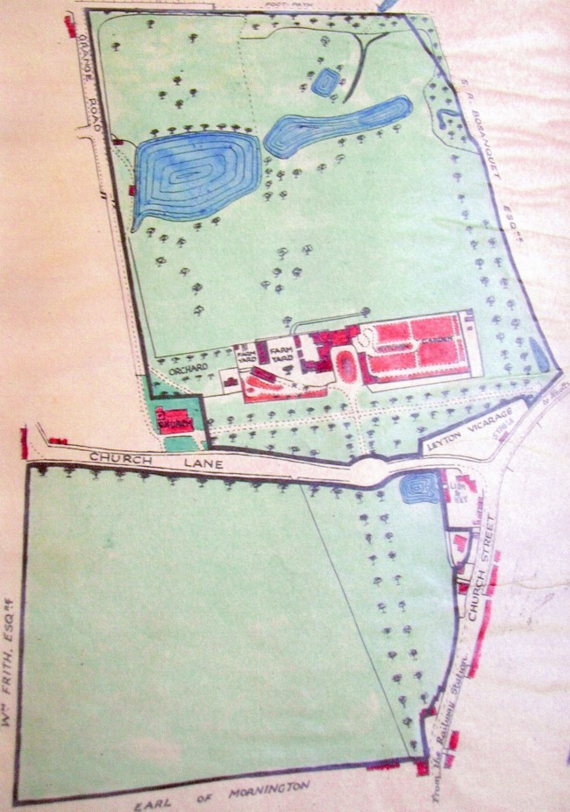

Plan of the Leyton Grange Estate, British Land Company, 1860

It was the arrival of railway which finally saw the demise of The Grange and its estate. The Eastern Counties Railway which ran a branch line from Stratford through to Loughton, with intermediate stations at Leyton and Leytonstone, was opened in 1856. The Grange was set to become the first estate to be sold for building that started the transformation of a village into a London suburb. The Grange remained empty from March 1859 until April 1860, when it was shown as owned by Rev Charles Lane. Lister Lane, of The Grange Lodge, acted as the late John Lane’s representative, when the Grange was finally sold off for £13,150. The remaining lands were sold to the British Land Company in 1860 by John Pardoe, the grandson of his namesake and these were offered for sale by a Mr Whittingham on 27 September 1860. The house was demolished and most of the trees felled in 1861 when the grounds were laid out as building plots.

As a postscript, what has never been satisfactorily traced is the whereabouts of a copy of a painting of Henrietta Maria, after Anthony Van Dyke, which hung in the drawing room. It is probably the same painting mentioned by Samuel Pepys which he recorded seeing at Ruckholt House in September 1665. W H Weston recorded that the painting passed into the possession of the Rothschild family.

The last of the Grange Estate?

Illustrations

The illustrations marked with an asterisk * are by arrangement with Vestry House Museum, London Borough of Waltham Forest. We are very grateful to the Museum’s staff for all the help they gave whilst this publication was being compiled.

Front cover : Elevation of David Gansel Esq, his house at Leyton Grange in Essex. Designed and built by himself 1720. Appeared in the Third Volume of Vitruvius Britannicus (or the British Architect), published in 1731.

Pages 5 and 6 : Elevation and plan dated 1720. Appeared in the Third Volume of Vitruvius Britannicus (or the British Architect), published in 1731.

Page 9 : John Rocque’s Map of 1746.

Page 17 : Plan of the Leyton Grange Estate, British Land Company, 1860* Map carefully coloured by Rev Robert Bren, November 1933.

Page 18 : Photograph February 2007 of the remaining tree standing on the Grange Estate.

Rear cover : Leyton Grange in the County of Essex, the seat of David Gansel Esq., was designed and executed it himself. Engraved by T Schynvoet c1720/3. Published in Le Noveau Theatre de la Grande Bretagne (aka Britannia Illustrated), four volume edition of 1729.

__________________________________________________________________________________

In Rev Robert Bren’s grangerised version of John Kennedy’s History of the Parish of Leyton Phelp Brothers, Leyton 1894 (vol 5 pp271 to 282). Held by the Vestry House Museum.
The History of Leyton, an extract from the Victoria County History of Essex, printed by the London Borough of Waltham Forest, 1979, p 13.
Leyton Past, an occasional publication on the history of the Leyton area, #4 March 1976, p 3.
Proceedings of the Huguenots Society Vol XXII no 6, 1982, pp 361.
Information from an incomplete memorial slab situated in the aisle of St Mary’s Parish Church. Originally stated that Charles Marescoe, his son Charles and daughter Mary were all buried here. See Old Leyton Church, Mary Savell, Church Publishers, Ramsgate nd (c1963).
Leyton Rate Books - all the Parish records still extant are held by the Vestry House Museum. All further references to births/marriages/deaths etc. come from the parish records.
Lady Day 25 March, one of the quarter days when payment of rates etc fell due.
Leytonstone Express & Independent, 24 September 1927. The transcript of Leyton and District in Roman Times, is held in the Vestry House Museum. This paraphrased from Richard Gough’s edition of William Camden’s Britannic.
Court Rolls 17 June 1720 Vestry House Museum (L.72.2).
Colen Campbell also designed Wanstead House.
Notes compiled by Frederick Temple, Vestry House Museum (L72.2).
Rev John Kennedy History of the Parish of Leyton, Essex Phelp Brothers, Leyton 1894 pp 317.
High Street, now High Road, incorrectly called Church Street on the map of 1860.
Rev F W Wilkinson A History of Leyton, 1897 p 20.
Mr (later Rev) Inskip, letter to The District Times, 1903. Pasted into Rev Robert Bren’s grangerised version of John Kennedy’s History of the Parish of Leyton Phelp Brothers, Leyton 1894 .
R. Day, letter to commenting on Mr Inskip’s published letter, dated 2 May 1907. Pasted into Rev Robert Bren’s grangerised version of John Kennedy’s History of the Parish of Leyton Phelp Brothers, Leyton 1894 .
C H Crouch, note in Rev Robert Bren’s grangerised version of John Kennedy’s History of the Parish of Leyton Phelp Brothers, Leyton 1894
Information from a Mr Miller and recorded by Frederick Temple, Vestry House Museum (L72.2).
Note recorded by Frederick Temple, Vestry House Museum (L72.2).
Information from a Mr A J Wintersgill and recorded by Frederick Temple, Vestry House Museum (L72.2).
Information from E Sydney and recorded by Frederick Temple, Vestry House Museum (L72.2). Whereabouts now unknown.
Rev. Daniel Lysons The Environs of London: volume I: Counties of Kent, Essex & Herts (1809).
Michaelmas Day 29 September, one of the quarter days when payment of rates etc fell due.
The History of Leyton, an extract from the Victoria County History of Essex, printed by the London Borough of Waltham Forest, 1979, p 34.
Watercolour of his tomb is in the Wakefield Collection, Guildhall Library. The tomb stood just off the main path opposite the Alms-Houses.
From title deeds of the British Land Company and copied by Rev Robert Bren.
Another child, a second daughter, Jane, was born on 21 May 1791, and died two months later on 21 July 1791.
William Charles Cotton, born 1786, died and buried Leytonstone 1866. Became Governor of the Bank of England from 1842 to 1845.
From title deeds of the British Land Company and copied by Rev Robert Bren.
Farm and Household account book 1798 - 1818, held by the Waltham Forest Archives at the Vestry House Museum.
Rev John Kennedy History of the Parish of Leyton, Essex Phelp Brothers, Leyton 1894 pp 210.
Now the site of Bridgetown International Airport.
Newton Family Papers (catalogue MS/523) held by the University of London Library. The collection numbering over a thousand items was mostly acquired by the University in 1960/1.
For further information on Newtons Plantation see Plantation Slavery in Barbados, Jerome Handler, Harvard University Press, Cambridge, 1978.
Cecil John Rhodes 1853 - 1902 Known as the Father of Rhodesia and founder of De Beers Mining Company.
The Parish of the Church of St John Zachery in Maiden Lane, the old Goldsmiths’ Church, destroyed in the Great Fire of 1666. Not rebuilt.
For further information on this railway, see How the Railway came to Leytonstone, Alan Simpson, Leyton & Leytonstone Historical Society, 2006.
# From title deeds of the British Land Company and copied by Rev Robert Bren.
Rev F W Wilkinson, A History of Leyton, Leyton 1897, p 20.
Samuel Pepys - Diary entry 13 September 1665 - I was only pleased at a very fine picture of the Queene-Mother, when she was young, by Van-Dike; a very good picture, and a lovely sweet face.
W H Weston, The Story of Leyton and Leytonstone, A Wheaton & Co, Exeter 1921. P 183.

